WP Lab week-2

Q1. Write a JavaScript program to perform an online quiz  
  
<!DOCTYPE html>

<html lang="en">

<head>

<meta charset="UTF-8">

<meta name="viewport" content="width=device-width, initial-scale=1.0">

<title>Quiz</title>

<style>

body {

font-family: Arial, sans-serif;

margin: 0;

padding: 0;

background-color: #f4f7f6;

}

.container{

display: flex;

justify-content: center;

align-items: center;

height: 100vh;

width: 100vw;

}

.item{

border: 2px solid #4CAF50;

border-radius: 1rem;

padding: 2rem;

background-color: white;

box-shadow: 0 4px 8px rgba(0, 0, 0, 0.1);

width: 300px;

text-align: center;

}

.item h2 {

margin-bottom: 20px;

font-size: 1.5rem;

color: #333;

}

label {

font-size: 1.1rem;

color: #333;

display: block;

margin-bottom: 15px;

}

input[type="radio"] {

margin: 10px;

transform: scale(1.2);

}

button {

padding: 10px 20px;

background-color: #4CAF50;

color: white;

border: none;

border-radius: 0.5rem;

font-size: 1rem;

cursor: pointer;

margin-top: 15px;

width: 100%;

}

button:hover {

background-color: #45a049;

}

.result {

font-size: 1.2rem;

margin-top: 20px;

color: #555;

}

.score {

font-size: 1.3rem;

margin-top: 30px;

color: #333;

}

</style>

</head>

<body>

<div class="container">

<div class="item">

<h2>Country Quiz</h2>

<form onsubmit="handleSubmit(event)">

<label>Which is the biggest country?</label><br>

<input type="radio" name="q1" class="q1" value="india"> India <br>

<input type="radio" name="q1" class="q1" value="china"> China <br>

<input type="radio" name="q1" class="q1" value="russia"> Russia <br>

<input type="radio" name="q1" class="q1" value="australia"> Australia <br>

<label>Which country has the most population?</label><br>

<input type="radio" name="q2" class="q2" value="india"> India <br>

<input type="radio" name="q2" class="q2" value="china"> China <br>

<input type="radio" name="q2" class="q2" value="usa"> USA <br>

<input type="radio" name="q2" class="q2" value="brazil"> Brazil <br>

<label>Which country is known as the Land of the Rising Sun?</label><br>

<input type="radio" name="q3" class="q3" value="india"> India <br>

<input type="radio" name="q3" class="q3" value="china"> China <br>

<input type="radio" name="q3" class="q3" value="japan"> Japan <br>

<input type="radio" name="q3" class="q3" value="thailand"> Thailand <br>

<button type="submit">Submit</button>

</form>

<div id="result" class="result"></div>

<div id="score" class="score"></div>

</div>

</div>

<script>

const radioButtons1 = document.getElementsByClassName('q1');

const radioButtons2 = document.getElementsByClassName('q2');

const radioButtons3 = document.getElementsByClassName('q3');

let selectedAnswers = {

q1: null,

q2: null,

q3: null

};

// Listen for changes in each question's radio buttons

for (let i = 0; i < radioButtons1.length; i++) {

radioButtons1[i].addEventListener('change', function(event) {

selectedAnswers.q1 = event.target.value;

});

}

for (let i = 0; i < radioButtons2.length; i++) {

radioButtons2[i].addEventListener('change', function(event) {

selectedAnswers.q2 = event.target.value;

});

}

for (let i = 0; i < radioButtons3.length; i++) {

radioButtons3[i].addEventListener('change', function(event) {

selectedAnswers.q3 = event.target.value;

});

}

// Correct answers for each question

const correctAnswers = {

q1: 'russia',

q2: 'china',

q3: 'japan'

};

function handleSubmit(e) {

e.preventDefault();

let score = 0;

for (let question in selectedAnswers) {

if (selectedAnswers[question] === correctAnswers[question]) {

score++;

}

}

const resultElement = document.getElementById('result');

const scoreElement = document.getElementById('score');

if (score === 3) {

resultElement.innerHTML = '<span style="color: green;">Correct! You got all questions right!</span>';

} else {

resultElement.innerHTML = `<span style="color: red;">You got ${score} out of 3 questions right!</span>`;

}

scoreElement.innerHTML = `Your Score: ${score}/3`;

}

</script>

</body>

</html>

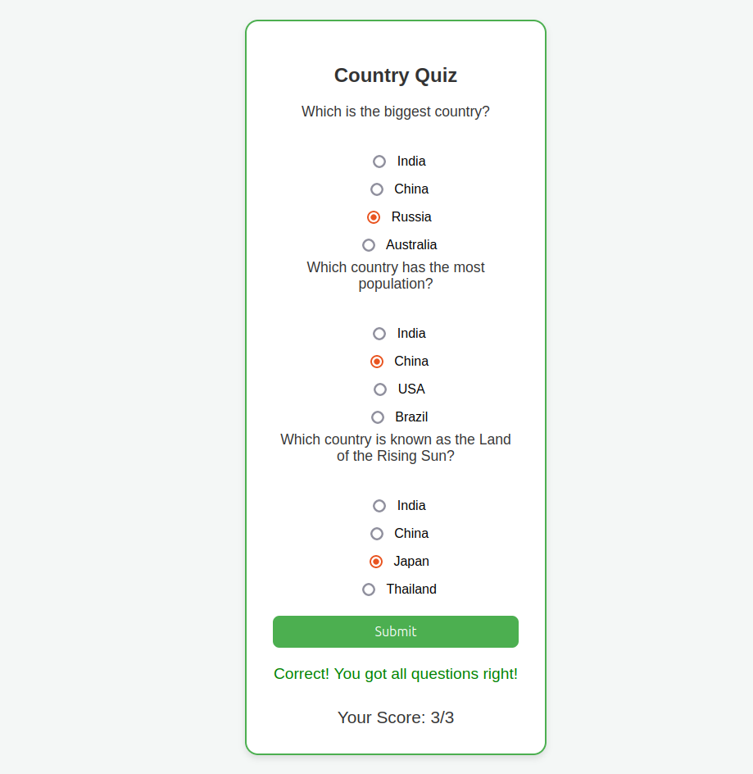

Q2. Write a JavaScript program to Wish a user at different hours of a day. Use

appropriate dialog boxes for wishing the user. Display the dynamic clock on the

web page. Make use of CSS and HTML5 elements for creative and attractive

design

<!DOCTYPE html>

<html lang="en">

<head>

<meta charset="UTF-8">

<meta name="viewport" content="width=device-width, initial-scale=1.0">

<title>Clock with Greetings</title>

<style>

body {

font-family: 'Arial', sans-serif;

background: #f0f0f0;

margin: 0;

padding: 0;

}

.container {

display: flex;

justify-content: center;

align-items: center;

height: 100vh;

flex-direction: column;

}

.clock {

font-size: 3em;

font-weight: bold;

background: #fff;

padding: 20px;

border-radius: 10px;

box-shadow: 0 4px 8px rgba(0, 0, 0, 0.1);

margin-bottom: 20px;

}

.greeting {

font-size: 2em;

color: #333;

margin-top: 10px;

}

.time-message {

font-size: 1.5em;

color: #777;

}

.time-message span {

font-weight: bold;

}

</style>

</head>

<body>

<div class="container">

<div class="clock" id="clock"></div>

<div class="greeting" id="greeting"></div>

</div>

<script>

function displayTime() {

const date = new Date();

let hour = date.getHours();

let minute = date.getMinutes();

let second = date.getSeconds();

minute = minute < 10 ? '0' + minute : minute;

second = second < 10 ? '0' + second : second;

const timeString = `${hour}:${minute}:${second}`;

document.getElementById('clock').textContent = timeString;

let greetingMessage = '';

if (hour < 12) {

greetingMessage = 'Good Morning!';

} else if (hour < 17) {

greetingMessage = 'Good Afternoon!';

} else {

greetingMessage = 'Good Evening!';

}

document.getElementById('greeting').textContent = greetingMessage;

const timeMessage = `It's currently ${hour} : ${minute} : ${second}`;

document.getElementById('timeMessage').textContent = timeMessage;

}

setInterval(displayTime, 1000);

displayTime();

</script>

</body>

</html>

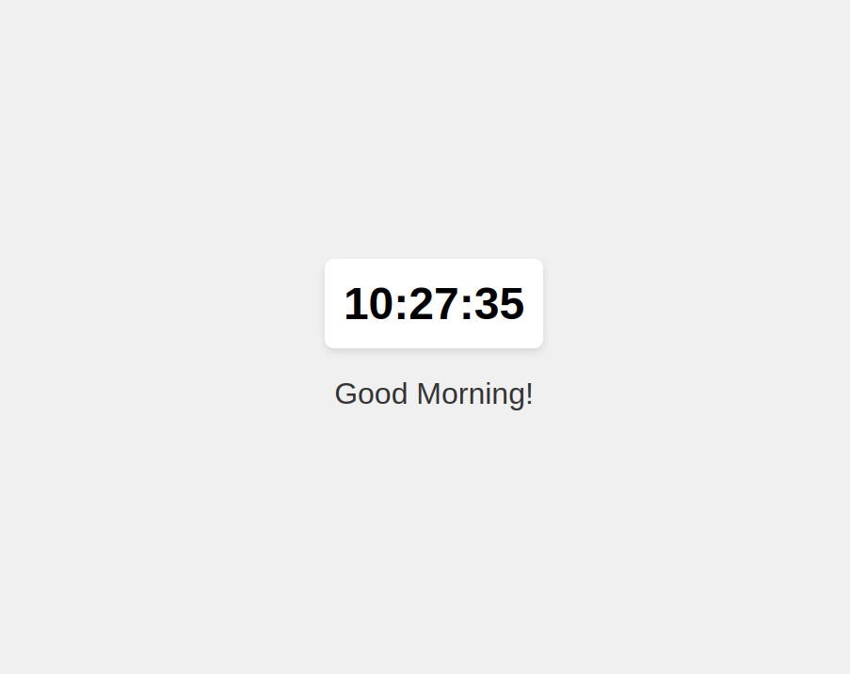

Q3. Write the java script program to display the grade [A, B,C,D] based on the marks entered by student(take the input into text boxes). Enter the marks of 4 subjects and calculate the average( using button). If the avg>90 then A, avg>80 then B, if avg>70 then C, if avg>60 then D.

<!DOCTYPE html>

<html lang="en">

<head>

<meta charset="UTF-8">

<meta name="viewport" content="width=device-width, initial-scale=1.0">

<title>Grade Calculator</title>

<style>

body {

font-family: Arial, sans-serif;

background-color: #f4f4f4;

margin: 0;

padding: 0;

display: flex;

justify-content: center;

align-items: center;

height: 100vh;

}

.container {

background-color: #fff;

padding: 20px;

border-radius: 10px;

box-shadow: 0 4px 8px rgba(0, 0, 0, 0.1);

width: 300px;

}

h2 {

text-align: center;

color: #4CAF50;

}

label {

font-weight: bold;

margin-top: 10px;

}

input {

width: 100%;

padding: 8px;

margin: 5px 0 10px 0;

border: 1px solid #ccc;

border-radius: 5px;

font-size: 16px;

}

button {

background-color: #4CAF50;

color: white;

padding: 10px;

border: none;

border-radius: 5px;

width: 100%;

font-size: 16px;

cursor: pointer;

}

button:hover {

background-color: #45a049;

}

#result {

margin-top: 20px;

font-size: 18px;

font-weight: bold;

text-align: center;

}

#result.A {

color: green;

}

#result.B {

color: #4CAF50;

}

#result.C {

color: orange;

}

#result.D {

color: #FF9800;

}

#result.F {

color: red;

}

</style>

</head>

<body>

<div class="container">

<h2>Grade Calculator</h2>

<label for="marks1">Marks for Subject 1:</label>

<input type="text" id="marks1"><br>

<label for="marks2">Marks for Subject 2:</label>

<input type="text" id="marks2"><br>

<label for="marks3">Marks for Subject 3:</label>

<input type="text" id="marks3"><br>

<label for="marks4">Marks for Subject 4:</label>

<input type="text" id="marks4"><br>

<button onclick="calculateGrade()">Calculate Grade</button>

<p id="result"></p>

</div>

<script type="text/javascript">

function calculateGrade() {

var marks1 = parseFloat(document.getElementById("marks1").value);

var marks2 = parseFloat(document.getElementById("marks2").value);

var marks3 = parseFloat(document.getElementById("marks3").value);

var marks4 = parseFloat(document.getElementById("marks4").value);

if (isNaN(marks1) || isNaN(marks2) || isNaN(marks3) || isNaN(marks4)) {

alert("Please enter valid numbers for all subjects.");

return;

}

var avg = (marks1 + marks2 + marks3 + marks4) / 4;

var grade;

if (avg > 90) {

grade = "A";

} else if (avg > 80) {

grade = "B";

} else if (avg > 70) {

grade = "C";

} else if (avg > 60) {

grade = "D";

} else {

grade = "F";

}

document.getElementById("result").innerHTML = "Average: " + avg.toFixed(2) + "<br>Grade: " + grade;

document.getElementById("result").className = grade;

}

</script>

</body>

</html>

